## Exploring Connecticut’s Changing Landscape Story Map

CCL Story Map

Day 1

How is Connecticut’s landscape changing? Where? How fast? This story map was designed to answer these questions through a combination of facts, statistics and maps. Connecticut’s Changing Landscape is a remote sensing-based land cover study that examines landscape changes over a 25 year period from 1985-2010. In this activity, you will explore the interactive story map by reading and clicking through the different tabs. We encourage you to click on the maps to explore the state and your specific communities!

### Open the Connecticut’s Changing Landscape Story Map

The University of Connecticut’s Center for Land Use Education and Research (CLEAR) has created a number of interactive story maps for Connecticut. For this activity, you will explore the Connecticut’s Changing Landscape Story Map. Let’s get started.

* First open a **web browser** (Google Chrome, Mozilla Foxfire, etc.)
* Go to the UConn CLEAR website, **“clear.uconn.edu”**
* Scroll down the Home page to the Featured section, and click on **“CLEAR Story Map Gallery”**
* Finally click on **“Connecticut’s Changing Landscape”** in the bottom left corner of the screen

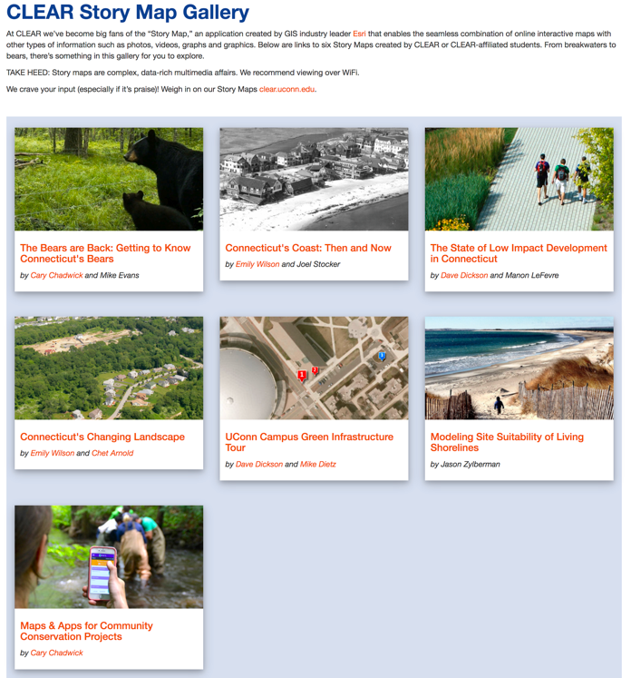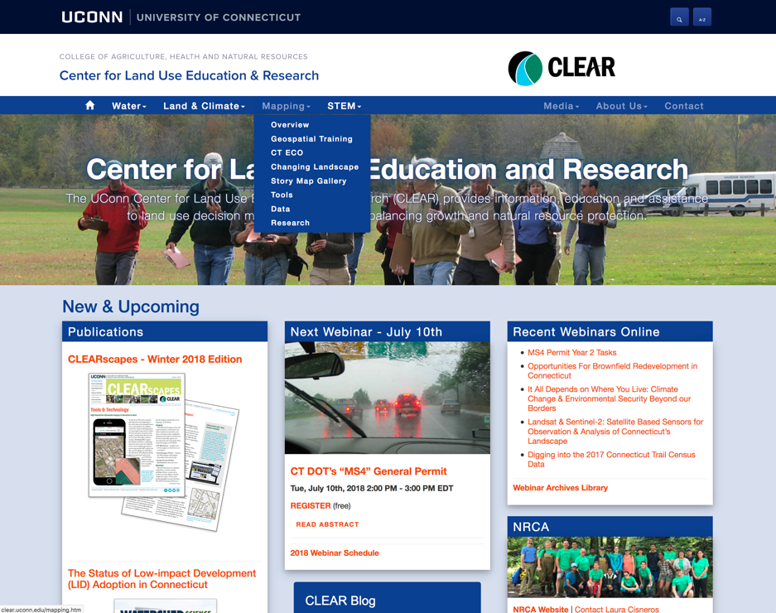

**http://clear.uconn.edu**

**http://clear.uconn.edu/storymaps**

### Explore the Connecticut’s Changing Landscape Story Map

1. Take a few minutes to explore the story map. You can scroll down through the “pages” of the story using the dots on the right-hand side. You’re just browsing so don’t dwell on any one page for the moment – you’ll be back!

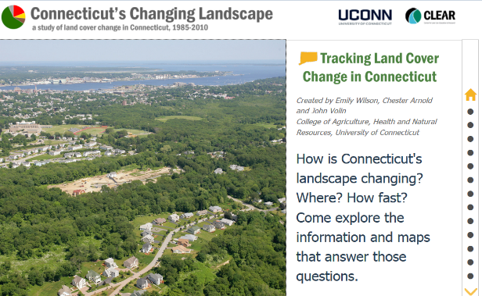

*The story map is divided into pages*

2. Now, return to Page 2 (the second dot) to look into the land cover in your town. You can pan and zoom on the map using the Spyglass tool. To really check out your town, click on one of the example towns, which will turn the entire map into a land cover map. Then, pan & zoon to your town. Click anywhere in your town to see a box showing the land cover distribution.

## **Q**: *What is the most common land cover in your town? _________________________*

3. The next four pages highlight the four major land covers in the state: forest, developed land, turf & grass, and agricultural fields. You can view the data by pixel, or averaged by town. And you can see both of these maps showing the situation in 2010, or showing the change from 1985-2010. There are also links to pre-set examples showing changes in that particular land cover, statewide statistics, and a graph of statewide change over the 25 years.

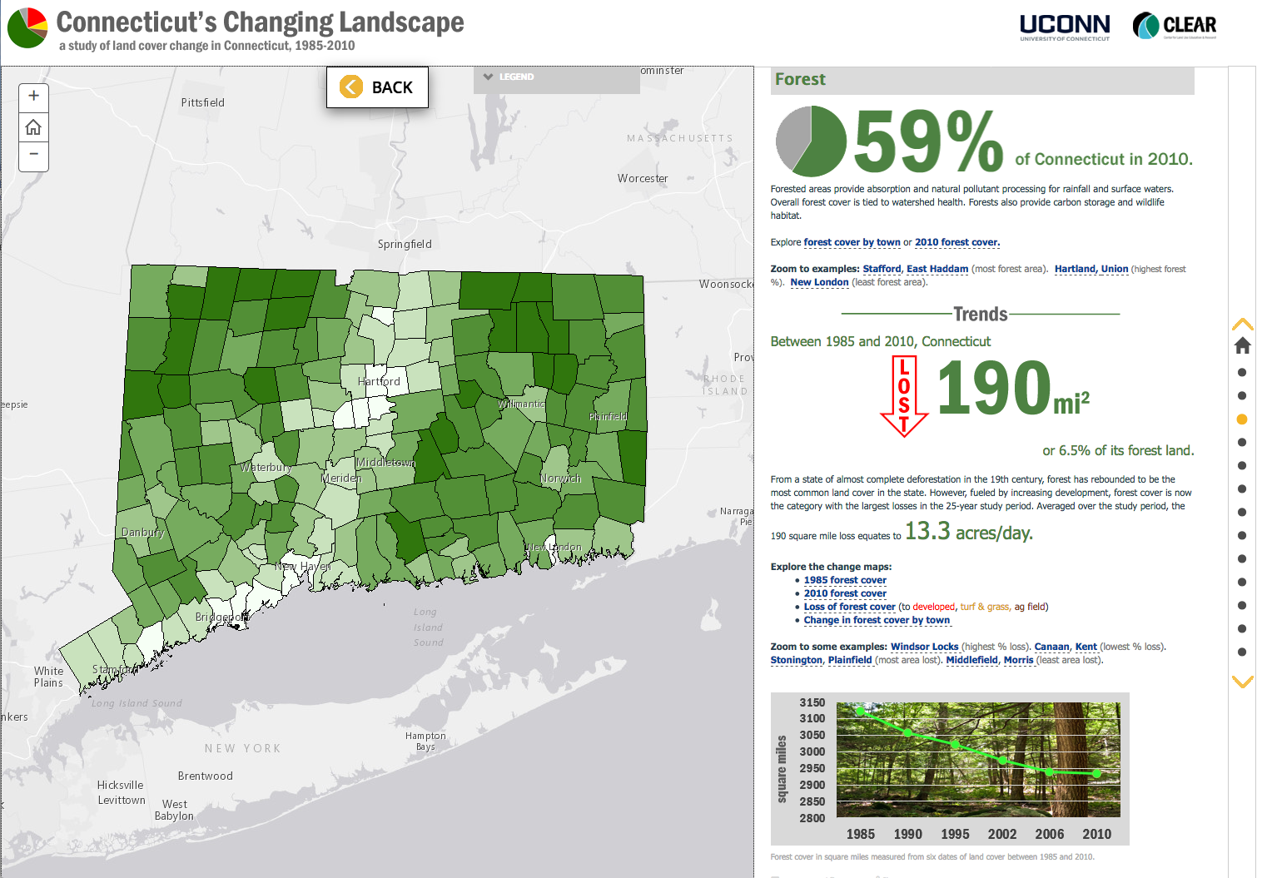

*Status maps*

*Change maps*

*Graph of change over time*

*Examples*

*Statewide change stats*

## **Q**: *How many acres of forest did your town lose between 1985 and 2010? _______________*

## **Q**: *How many acres of agricultural field did Suffield have in 1985? ______ In 2010? ______*

**Q:** *How many average acres per day of Turf & Grass did CT gain during the 25-year period?*

*___________*

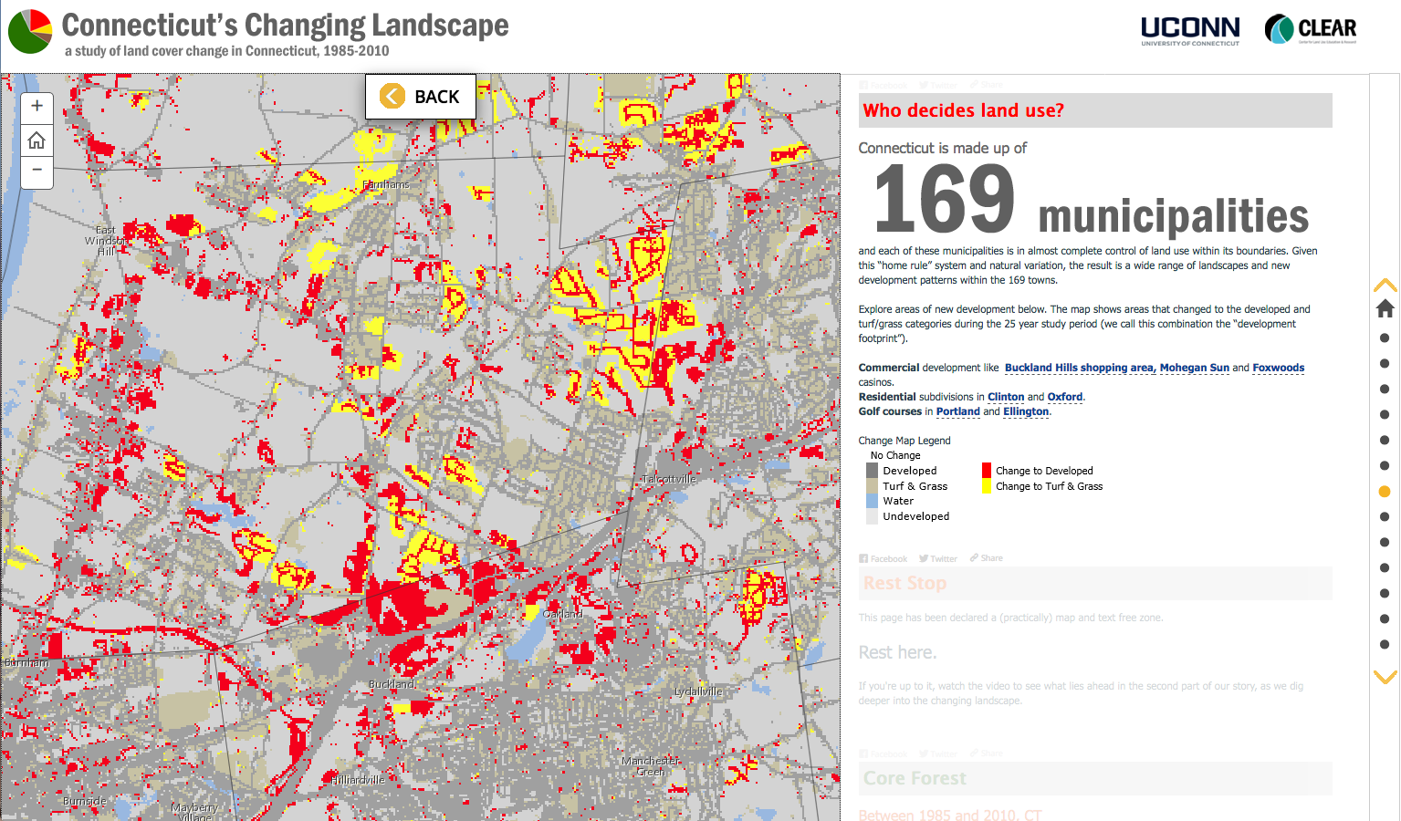

examples

4. Go to Page 7 (Who decides land use?) and explore the pre-set examples of the “development footprint” in those towns to get a feel for the patterns that indicate each type of development. Then, zoom to your town and analyze the areas that have changed to developed or turf and grass. Where is the majority of change happening? For example, does it occur along a water source, close to a major roadway, or extending from a pre-existing shopping area? Think about the location, amounts and pattern of development in your town and the possible impacts (both good and bad) it has had on your community.

**Q**: *Describe the development pattern in your town over the 1985-2010 period.*

5. Go to Page 8 (Rest Stop) and watch the brief video on daily landscape change in CT.

6. Choose one of the four new analytical maps on Pages 9-12, and poke around. Whatever strikes your fancy: there are chapters on forest fragmentation, riparian zones, agricultural land, and impervious surfaces.

## **Q**: *Which map did you choose? _______________*

## *If you had to encapsulate the information of this map in one sentence, what would it be?*

insert brilliant incisive sentence here